
QUALITY ALERT

Customer: ChamClad Date: October 04, 2022
Die: 15766 Customer NCR:
Type of Complaint: ChamClad REJECT

Description: ChamClad REJECTED – Material has the leg which is too straight – can NOT snap in easily.
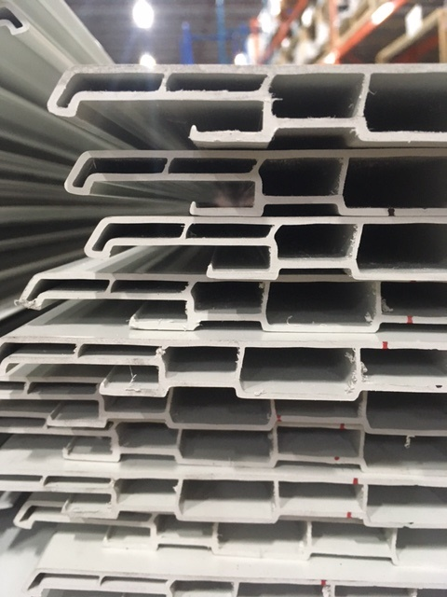

BAD

THE LEG IS TOO STRAIGHT – DIFFICULT TO SNAP
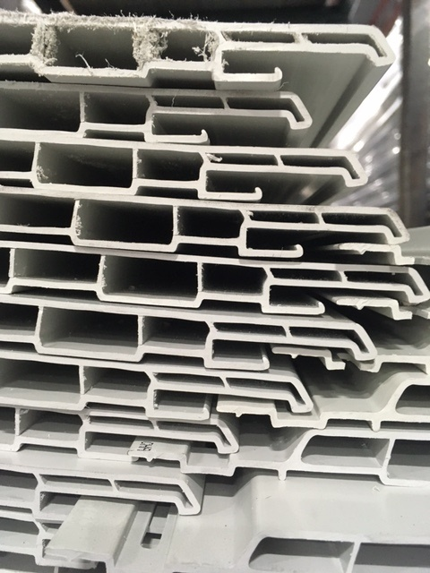

GOOD

MAKE SURE MATERIAL RUN THE CURVED LEG
BY SIGNING BELOW, YOU ACKNOWLEDGE THE PROBLEM ABOVE AND AGREE TO MONITOR THIS ISSUE IN FUTURE PRODUCTION RUNS.
DAY SHIFT |  | AFTERNOON SHIFT |  | NIGHT SHIFT
NAME | SIGNATURE | NAME | SIGNATURE | NAME | SIGNATURE

